

A Level Chemistry

UNIT 2

APPLICATION OF CORE PRINCIPLES OF CHEMISTRY

NOTES

Written by Mr Sergeant and Dr Lawrence

Introduction

This unit includes the following.
- Shapes of molecules and ions. Intermediate bonding and bond polarity.
- Consideration of intermolecular forces.
- The study of the Periodic Table looking at Groups 2 and 7.
- Redox reactions, particularly those concerning Group 7 elements and their compounds.
- Rate of reaction (kinetics)
- Chemical equilbria
- Organic chemistry; alcohols and halogenoalkanes.
- Mechanisms
- Mass and infrared spectrometry
- Green chemistry.

Assessment

The Unit examination will be 1hour 15 minutes. It will carry 80 marks.

It will contain three sections, A, B and C.

Section A is an objective test – multiple choice questions.

Section B short-answer and extended answer questions.

Section C will contain extended answer questions on contemporary contexts.

Questions on the analysis and evaluation of practical work will also be included in either section B or C.
Quality of written communication will be assessed in sections B and C.

SHAPES OF MOLECULES AND IONS

The shape of a molecule depends upon its electronic structure. It is the outer shell or valence shell electrons which are responsible for forming bonds and it is the arrangement of these electrons which determine molecular shape.
The electrons are all negatively charged and so will repel each other.
Each electron region takes up a position to minimise repulsion.
By considering the valence shell electron regions and their positions according to repulsive effects we can explain the shape of molecules.
This is called the electron pair repulsion theory.

Beryllium chloride, BCl₂

Dot and cross diagram.
Beryllium chloride has two bonding pairs in the valence shell. These position themselves as far apart as possible – at 180º. The molecule is linear.
Be
Cl
Cl

Be
Cl
Cl
180^{O}

Boron trifluoride, BF₃

Dot and cross diagram.
B
F
F
F
B
F
F
F
120^{O}

There are three bonding pairs (electron area in a bond); these will spread the maximum distance apart - that is at an angle of 120º.

This molecule is flat, that is it lies in a plane; such a molecule is said to be planar. With three bonds at an angle of 120º BF₃ is said to be trigonal planar.

Methane, CH₄

Dot and cross diagram.
Methane has four bonding electron pairs in the valence shell. These position themselves as far apart as possible to form a tetrahedral shape with a bond angle of 109.5º.
C
H
H
H
H

C
H
H
H
H
109.5^{O}

Ammonia, NH₃
Ammonia has three bonding electron pairs and a lone pair of electrons in the valence shell. These position themselves as far apart as possible, but the lone pair has a greater repulsion than the bonding pairs pushing the bonding pairs closer together and reducing the bond angle to 107.5º.
The molecule is pyramidal.
Dot and cross diagram.

N
H
H
H

N
H
H
H
107.5^{O}

Water, H₂O

Dot and cross diagram. Molecule
O
H
H
O
H
H
104.5^{O}

Water has two bonding electron pairs and two lone pairs of electrons in the valence shell. The two lone pairs have a greater repulsion than the bonding pairs, pushing the bonding pairs closer together and reducing the bond angle to 104.5º.
The molecule is bent.

Carbon dioxide, CO₂

Dot and cross diagram.
Carbon dioxide has two electron regions in the valence shell. These position themselves as far apart as possible.
The molecule is linear.

C
O
O

C
O
O
180^{O}
Molecule

Phosphorus pentachloride, PCl₅
Phosphorus pentachloride has five bonding electron pairs in the valence shell.
The molecule is trigonal bipyramidal.
P
Cl
Cl
Cl
Cl
Cl

P
Cl
Cl
Cl
Cl
Cl
120^{O}
90^{O}

Two of the bonds are at 180º. The other three are in a plane at 120º.

Sulphur hexafluoride, SF₆

Dot and cross diagram.
S
F
F
F
F
F
F
Sulphur hexafluoride has six bonding electron pairs in the valence shell.
The molecule is octahedral with bond angles of 90º

S
F
F
F
F
F
F
90^{O}

Ammonium ion, NH₄⁺
N
H
H
H
H
+

The ammonium ion has four bonding pairs of electrons in the valence shell (one of theses being a dative bond). The molecule is tetrahedral with bond angles of 109.5º.

N
H
H
H
H
+

Bond angles in CH₄, NH₃, H₂O
It is important to note that although there are four pairs of electrons arranged approximately tetrahedrally around the N in NH₃ and the O in H₂O, the lone pairs cannot be “seen” experimentally, so the shapes of these molecules are described by the actual positions of the atoms: ammonia is pyramidal and water is bent.

We can explain the differences in the bond angles in CH₄, NH₃ and H₂O by noting that repulsions get less along the series:
lone pair/lone pair > lone pair/bonding pair > bonding pair/bonding pair

This occurs because a lone pair is closer to the nucleus of the atom, and so takes up more room than a bonding pair. When this principle is applied to CH₄, NH₃ and H₂O, CH₄ is a regular tetrahedron (angles of 109.5º); NH₃ has one lone pair, which squashes the H atoms down (angles reduced to 107º); and H₂O has two lone pairs, which repel the H atoms even more (angle now 104.5º):
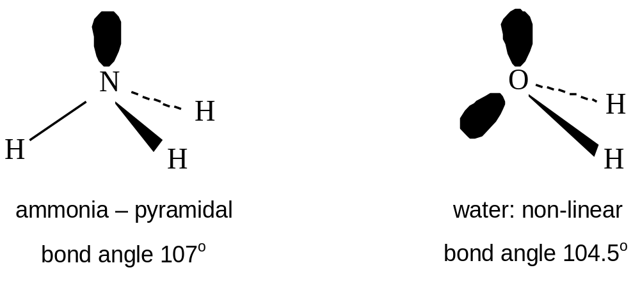
ammonia – pyramidal
bond angle 107º
water – non-linear
bond angle 104.5º
More complicated molecules

The shapes of more complicated molecules and ions can also be “explained” by electron pair repulsion theory, or EPR.
In applying this principle, we must include both bonding and non-bonding (or “lone”) pairs, and we must count a double or triple bond as if it were one pair (or one region of electron density).
The table shows the shapes expected for different numbers of electron pairs.

Number of electron pairs | Shape | Bond angles | Examples
Two | linear | 180º | Ag(NH₃)₂⁺, CO₂
Three | Trigonal planar | 120º | CH₂=CH₂, BF₃
Four | tetrahedral | 109.5º | CH₄, NH₃*, H₂O
Six | octahedral | 90º | SF₆, Fe(CN)₆^{3–}

We can use advanced EPR theory to predict the shape of any molecule or ion.

1) Decide on the central atom Record its number of outer electrons

2) Count the number of bonding atoms Add 1 e- for each atom

3) If the species is – charged Add 1 e- for each charge

4) If the species is + charged Subtract 1 e- for each charge

5) Find the total number of electron pairs.

6) Determine the shape of the species;
Pairs Shape
- Linear
- Trigonal Planar
- Tetrahedral
- Trigonal bipyramidal
- Octahedral

7) Show any lone pairs.
The number of Lone pairs = Total number of pairs – bonding pairs
Example
Electrons
PH₄⁺ Central atom = P 5
Bonding atoms = 4 x H 4 (Forms 4 bonding pairs)
Positively charged -1

Total = 8 4 pairs = Tetrahedral

The number of Lone pairs = Total number of pairs – bonding pairs = 4-4 = 0
P
H
H
H
H
+

Example
Electrons
IF₄⁻ Central atom = I 7
Bonding atoms = 5 x F 4 ( Forms 4 bonding pairs)
Negatively charged +1

Total = 12 6 pairs = Octahderal

The number of Lone pairs = Total number of pairs – bonding pairs = 6-4 = 2
I
..
F
..
F
F
F
90^{O}
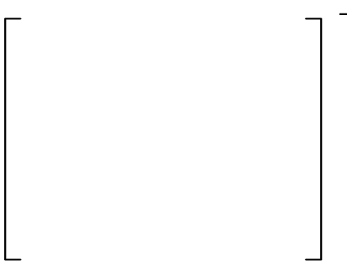
Structures of Carbon Allotropes

Diamond
Diamond is composed of carbon atoms. Each carbon atom is connected to four other carbon atoms

Each of these atoms is also connected to three other carbon atoms. In this way a giant structure is built up from these tetrahedral units.

This structure, held together by strong covalent bonds, is very difficult to break apart. So diamond has very high melting and boiling points. It is the hardest natural substance. Since all the electrons are taken up in bonding diamond is a non-conductor.
Diamonds are attractive which means they are used as jewellery. Its hardness makes it useful for cutting instruments such as drill tips.

Graphite
In graphite each carbon atom has three bonds, so three of the four electrons are taken up in forming these bonds. The remaining electron is allowed to move from atom to atom - it is delocalised.
Since three bonds form, the bond angle around each carbon is 120º and a hexagonal arrangement is set up.

These hexagons join together in a plane forming a sheet of hexagonally arranged carbon atoms.

Graphite is made up of these layers held together by London forces (Van der Waals' forces). Sometimes it is referred to as a layer structure.

The carbon atoms in graphite are held together by covalent bonds forming a giant structure, so the melting and boiling points are high. Since each atom has a free electron, graphite is able to conduct electricity. The layers held together by weak intermolecular forces can slide over each other, making a soft slippery substance.
Graphite can be used for electrodes as it is a conductor, and unlike metals it does not react during electrolysis. It can be used as a lubricant because of its slippery nature.

Fullerenes
Diamond and graphite were thought to be the only allotropes of carbon until late in the twentieth century. In 1985 a new form of carbon was discovered that consisted of spherical molecules containing 60 carbon atoms.

These molecules resembled the construction of a building by an architect called Buckminster Fuller. As a result, the molecule was named buckminsterfullerene. The molecule also resembles a football, so it is often called a “bucky-ball”.

Similar molecules have since been made that contain 70 or more carbon atoms. This family of molecules are called fullerenes.

Nanotubes

Another form of carbon developed as a result of the discovery of fullerenes is the nanotube.

The individual layers in graphite are called graphemes. A nanotube can be regarded as a grapheme which has rolled up to form a cylinder. The name comes from the diameter of the cylinder. A single-walled carbon nanotube is a one-atom thick sheet of graphite rolled up into a seamless cylinder with diameter 1-2 nm.

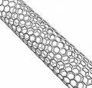

Such cylindrical carbon molecules have novel properties that make them potentially useful in many applications in nanotechnology, electronics, optics and other fields of materials science.
They exhibit extraordinary strength and unique electrical properties, and are efficient conductors of heat.

INTERMEDIATE BONDING AND INTERMOLECULAR FORCES

Electronegativity

Electronegativity is defined as follows
Electronegativity is the ability of an atom within a covalent bond to attract the bonding pair of electrons.

The table below shows electronegativity values of main block elements

 |  |  | H  2.1 |  |  |  |  |  | He
Li  1.0 | Be  1.5 |  |  | B  2.0 | C  2.5 | N  3.0 | O  3.5 | F  4.0 | Ne
Na  0.9 | Mg  1.2 |  |  | Al  1.5 | Si  1.8 | P  2.1 | S  2.5 | Cl  3.0 | Ar
K  0.8 | Ca  1.0 |  |  | Ga  1.6 | Ge  1.8 | As  2.0 | Se  2.4 | Br  2.8 | Kr
Rb  0.8 | Sr  1.0 |  |  | In  1.7 | Sn  1.8 | Sb  1.9 | Te  2.1 | I  2.5 | Xe
Cs  0.8 | Ba0.9 |  |  | Tl  1.8 | Pb1.8 | Bi  1.9 | Po  2.0 | At  2.2 | Rn

Polarisation of a covalent bond

A perfect covalent bond would consist of the bonding electron region being shared equally by each atom.

This occurs if each of the atoms have the same pull on the electron pair in the bond (equal electronegativity). It can be found in molecules of elements such as O₂, Br₂ and N₂. Since the atoms in each of these molecules are the same they will have the same electronegativity.

In most compounds however one atom will have a greater electronegativity than the other, and so will have a greater pull on the electrons, so distorting the electron region.

This process of moving away from the perfect example is called polarisation. The extent of the polarisation will depend on the difference in electronegativity of the two atoms.

The polarisation of a covalent bond will mean that one part of the molecule is more negative (the most electronegative atom) than the other and causing the bond to be polar.

Hydrogen chloride is an example of a molecule which contains a polar bond.
The chlorine possesses a higher electronegativity, so will draw the electron pair in the covalent bond towards itself.
δ+
δ-
H
Cl
2.1
3.0

Intermediate bonding
In Unit 1 (Ionic Bonding) it was noted that ionic compounds can be polarized which gives them a covalent character. When a molecule has a polar bond, it gives the covalent substance an ionic character.

To regard a compound as “covalent” or “ionic” is too simplistic for understanding AS chemistry. It is more correct to visualize type of bonding on a sliding scale where compounds can be described as “predominantly covalent” or “predominantly ionic”.

Electronegativity values can be used to give an approximate idea of the predominant type of bonding in a binary compound.

Electronegativity difference | 0.1 | 0.2 | 0.3 | 0.4 | 0.5 | 0.6 | 0.7 | 0.8
Percentage ionic character | 0.5 | 1 | 2 | 4 | 6 | 9 | 12 | 15
Electronegativity difference | 0.9 | 1.0 | 1.1 | 1.2 | 1.3 | 1.4 | 1.5 | 1.6
Percentage ionic character | 19 | 22 | 26 | 30 | 34 | 39 | 43 | 47
Electronegativity difference | 1.7 | 1.8 | 1.9 | 2.0 | 2.1 | 2.2 | 2.3 | 2.4
Percentage ionic character | 51 | 55 | 59 | 63 | 67 | 70 | 74 | 76
Electronegativity difference | 2.5 | 2.6 | 2.7 | 2.8 | 2.9 | 3.0 | 3.1 | 3.2
Percentage ionic character | 79 | 82 | 84 | 86 | 88 | 89 | 91 | 92

Looking at a selection of substances

Substance | Elect’y value 1 | Elect’y value 2 | Elect’y difference | % ionic ch’r
Chlorine, Cl₂ | 3.0 | 3.0 | 0 | 0
Ammonia, NH₃ | 3.0 | 2.1 | 0.9 | 19
Water, H₂O | 3.5 | 2.1 | 1.4 | 39
Calcium chloride, CaCl₂ | 3.0 | 1.0 | 2.0 | 63
Lithium oxide, Li₂O | 3.5 | 1.0 | 2.5 | 79
Potassium fluoride, KF | 4.0 | 0.8 | 3.2 | 92

If these are then plotted on the diagram below, it can be seen the type of bonding is a continuum rather than a black and white picture.

% ionic character
10 | 20 | 30 | 40 | 50 | 60 | 70 | 80 | 90 | 100
Cl₂ | NH₃ |  | H₂O |  |  | CaCl₂ | Li₂O |  | KF

H₂O

Polar bonds and Polar Molecules

The presence of a polar bond may or may not lead to the formation of a polar molecule. The carbon – chlorine bond is polar because the chlorine is more electronegative than the carbon.
C
Cl
δ+
2.5
3.0
δ-

H
To decide whether a molecule will be polar, it is necessary to look at where the centres of positive and negative charge are placed. A molecule of trichloromethane is polar
δ+

C
Centre of negative charge

Cl
Cl
Cl
δ-

Looking at a molecule of tetrachloromethane
C
Cl
Cl
Cl
Cl

Centre of both negative and positive charge

Since there is no separation of charge in tetrachloromethane this is not a polar molecule.

Another example of a molecule with polar bonds, but is non-polar overall is carbon dioxide.
δ-
δ+
δ-

C
O
O
2.5
3.5
3.5

One way of testing a substance to see if it is composed of polar molecules is to place an electrostatic charge near a jet of the liquid.

Burette nozzle

Charged rod
The charge on the polar molecule causes the molecules to be attracted to the charged rod.

The greater the angle of deflection the more polar the molecule.

INTERMOLECULAR FORCES

2.5

Forces of attraction must exist between atoms and molecules which are not chemically bonded because at a low enough temperature all substances become liquids or solids – even helium, which consists of inert, uncombined atoms.

The three types of Intermolecular force to be considered are:
Dipole - dipole attractions
London or van der Waals' forces,
and Hydrogen bonding.

Dipole - dipole attractions
These occur when a molecule has a permanent dipole.
It has been seen that in a molecule such as trichloromethane, CHCl₃, the electronic
charge is pulled towards the chlorine atoms because they have a greater electronegativity.
This results in a molecule which has a partial positive charge at one end and a partial negative charge at the other. This type of molecule is described as polar.

The separation of charge which exists in a polar molecule is called a diplole.

H
δ+

C

Cl
Cl
Cl
δ-

In a polar material there is an attraction between the positive charge in one molecule and the negative charge in the other.

- +
- +
This type of force between molecules is referred to as dipole-dipole attractions.
-
+
+
+
-
-
+
-
-
+
+
-

van der Waals' forces
Also called - London forces, instantaneous dipole - induced dipole interactions and dispersion forces.

When noble gases are cooled sufficiently they will condense. This shows that there must be some forces acting between the atoms. These forces are called van der Waals' forces.

The random motion of electrons around a nucleus produces a fluctuating dipole, which changes from one instant to the next. Each instantaneous dipole influences its neighbours, tending to induce a dipole in them, and this leads to an attraction.

In general a larger atom will have a greater number of electrons around it, leading to a larger fluctuating dipole. This means that van der Waals forces generally increase with relative molecular mass.
For example, in the alkanes boiling points increase steadily as RFM rises.

Molecules like liquid bromine, Br₂, and liquid argon, Ar (monatomic), can only have van der Waals forces since they have no permanent dipoles. However, even in polar molecules like HCl the van der Waals are the most important factor, as can be seen from the increasing boiling points of the hydrogen halides:

HCl (188K; dipole 1.05D) < HBr (206K; 0.80D) < HI (238K; 0.42D)

Along this series, boiling points rise with RFM because of the increased van der Waals forces, even though dipole moments are getting less.

Van der Waals’ forces are generally weak (of energy up to 5 kJ mol^{–1}, compared to 150–400 kJ mol^{–1} for most covalent single bonds) but they increase as molecular mass increases and as the number of electrons in the molecule increases so with large molecules the forces become large.

Boiling points of the noble gases
The boiling points of the noble gases illustrate this increase in strength of Van der Waal's forces with molecular mass.

Noble gas | Molecular mass | Boiling point
Neon | 20 | -246
Argon | 40 | -186
Krypton | 84 | -152
Xenon | 131 | -108
Radon | 222 | -62

As the molecular mass of the gases increases, the atoms contain more electrons and so the size of the van der Waal’s forces increases. As the attractive forces between the molecules increases, it becomes more difficult to separate the molecules from each other and so the boiling points increase.
Hydrogen Bonding

Hydrogen bonds, with energies usually in the range from 20-40 kJ mol^{–1}, are typically ten times as strong as van der Waals’ forces, and about one-tenth as strong as covalent bonds. Two conditions are necessary for formation of hydrogen bonds:

(i) A H atom must be covalently bonded to a highly electronegative atom usually N, O or F.

Hydrogen only has one electron which is used when hydrogen bonds to another element. The elements listed above are highly electronegative and so draw the electron pair in the bond towards themselves. This leaves the proton on the hydrogen exposed.
δ-
δ+

H
X

Proton exposed

(ii) The adjacent molecule must have a lone pair of electrons on an N, O or F atom.

The hydrogen, with its δ+ charge, is strongly attracted to the adjacent lone pair. This is more than just a polar attraction, and is strongly directional (along the line of the lone pair).

You need to draw it with the polar bonds and lone pairs marked.
δ-
δ+
δ-
δ+

H
X
Proton exposed
H
X

Lone pair
Hydrogen bond

Molecules which show hydrogen bonding between molecules include:
i) HF;
ii) all compounds with –OH groups, including water;
iii) all compounds with –NH– groups, including NH₃.

In addition these molecules can all hydrogen-bond to water.

Examples of hydrogen bonding
δ+
N
H
H
H
Ammonia
δ+
δ+
N
H
H
H

δ+

δ-
δ+
δ+

δ+
Water
O
H
H
δ+
δ+
δ-
δ+
O
H
H

δ-
δ-

δ-

Hydrogen fluoride
δ-
F
H
δ-
F
H
δ-

δ+
δ-
δ+

Intermolecular forces and physical properties

The greater the intermolecular force strength, the more difficult it is to separate the molecules and so the higher the melting and boiling points.
The strengths of the intermolecular forces are summarized below.

van der Waal’s | Dipole-dipole | Hydrogen bonding
Found in all molecular substances | Found in polar substances | Found in compounds where H id directly bonded to N,O or F
Weakest Strongest

The three molecules below illustrate the various strengths of these intermolecular forces.
H₃C
CH₃
CH₂

Propane is composed of non-polar molecules and so only has van der Waals forces between the molecules.

Methoxymethane has a similar molecular mass to propane, but has a higher boiling point because the molecules are polar, so there are dipole-dipole attractions as well as van der Waals forces.

Propane: b.p. = -42.2 ºC

H₃C
CH₃
O
δ+
δ-

Methoxymethane: b.p. = -24.8ºC

H₃C
OH
CH₂
δ+
δ-
Ethanol has hydrogen bonding which is significantly stronger than the other intermolecular forces and so a much higher boiling point than methoxymethane even though they have the same molecular mass.

Ethanol: b.p. = 78ºC

Boiling Points of the Alkanes

A graph plotting the boiling points of the alkanes is shown below.
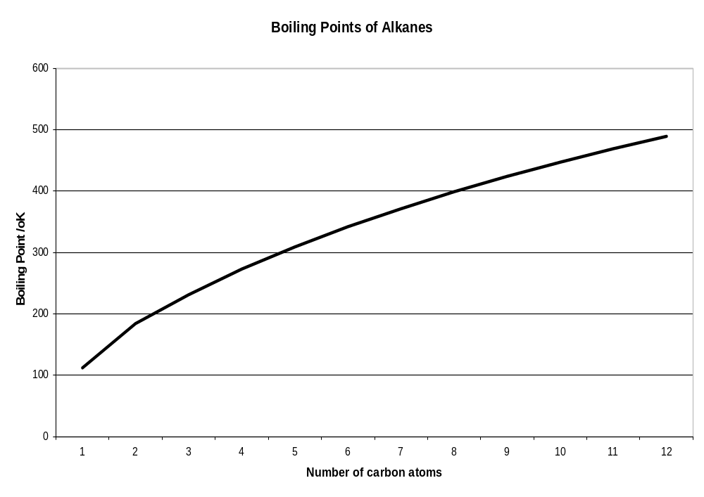
The boiling points of the alkanes increases with molecular mass. This happens because the higher the molecular mass, the greater the number of electrons and so the greater the chance of an imbalance and formation of an instantaneous dipole. The van der Waals’ forces (London forces) increase.
The melting point of the alkanes increases with molecular mass for the same reason, but the pattern is not so straightforward as the different packing of molecules in the solid according to whether the number of carbon atoms is odd or even causes an additional factor in the determination of the melting points.

The closer the molecules are able to approach each other, the greater the induction effect and so the greater the van der Waals’ forces. When an alkane has branching present, the molecules cannot approach each other so closely and there is less area over which contact can occur, so branched alkanes have lower boiling points.

The table below illustrates the effect of branching in alkane molecules on the boiling point.

Alkane | Molecular mass | Structural formula | Skeletal formula | Boiling point
Butane | 56 | CH₃CH₂CH₂CH₃ |  | -0.5ºC
Methylpropane | 56 | CH₃CH(CH₃)CH₃ | 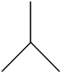 | -11.7 ºC

Boiling Points of the alcohols
The –OH group in alcohols causes hydrogen bonding between the molecules. Therefore an alcohol will have a much higher boiling point than an alkane with a similar number of electrons.

Alkanes |  |  | alcohol
Formula | Electron number | Boiling point | Formula | Electron number | Boiling point
CH₃CH₂CH₃ | 24 | -42 ºC | CH₃CH₂OH | 24 | 78.5 ºC
CH₃CH₂CH₂CH₃ | 32 | -0.5ºC | CH₃CH₂CH₂OH | 32 | 97ºC

Boiling Points of the hydrogen halides

The boiling points of HCl, HBr and HI increase with molecular mass. This is because as the number of electrons increases so does the chance of an electron imbalance and the formation of instantaneous dipoles and so greater van der Waals’ or London forces.

It might be expected that HF having a smaller molecular mass than HCl would have a lower boiling point. This is not the case. Hydrogen fluoride has the highest boiling point of this group because HF molecules form hydrogen bonds. The graph plotting the boiling points of hydrogen halides is shown below.
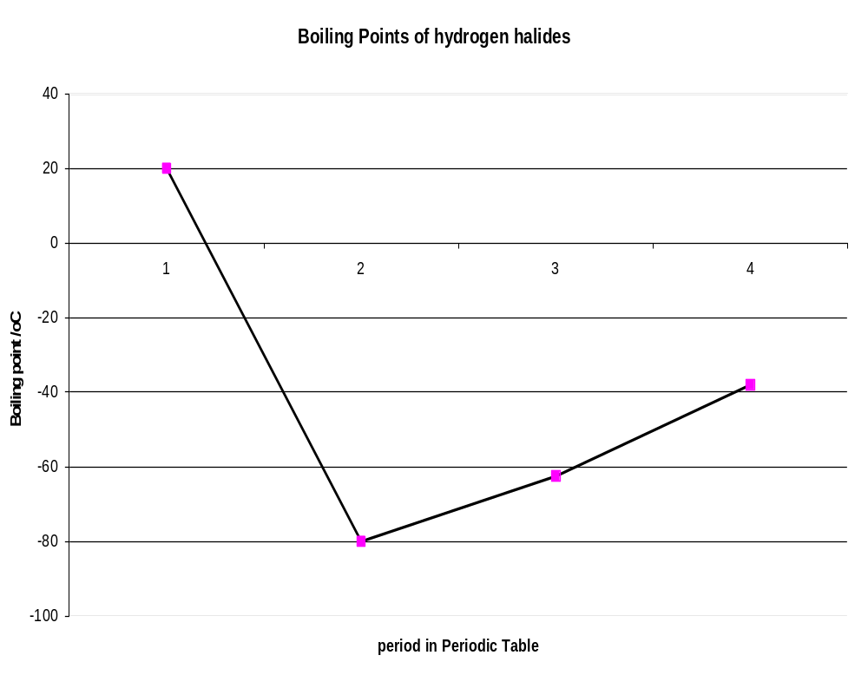

Boiling Points of other hydrides

Because hydrogen bonds are the strongest of the intermolecular forces, molecules with hydrogen bonding have higher boiling points, and higher enthalpies of vaporisation, than would otherwise be expected for molecules of similar molar masses.

We see this in the boiling points of the hydrides in groups 5, 6 and 7: in each case the first member (in the second period) is much higher than expected (see graph):

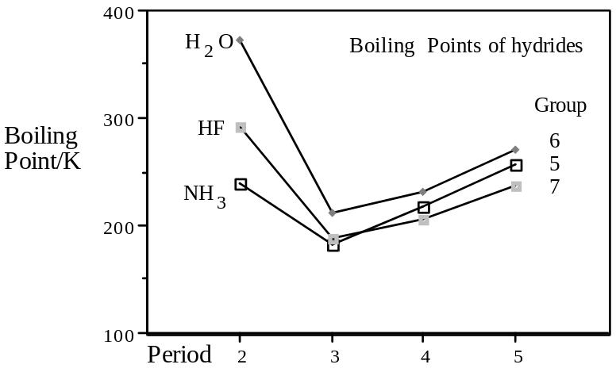

Unusual properties of water
The unusual properties of water are caused by hydrogen bonding:

(i) it has a much higher freezing and boiling point than expected for such a small molecule,
because it needs more energy to separate the molecules;

(ii) ice is less dense than water, whereas most solids are denser than their liquid phase.

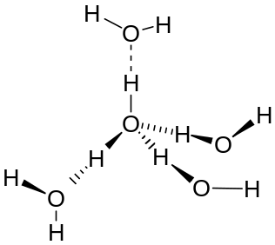In the structure of ice, for each water molecule the oxygen is bonded covalently to two hydrogens, and the two lone pairs of electrons each accept a hydrogen bond, so that the structure is tetrahedral (and not unlike that for diamond, though note that the O—H-----O distances are not the same as each other). The result is that ice has a rather open structure, with some empty space trapped in the lattice. This gives it a lower density than liquid water.
Solubility
In general a solvent will dissolve a substance that contains similar intermolecular forces.

Solubility of ionic compounds in water
When an ionic substance is placed in water, the water molecules, being highly polar, are attracted to the ions. The oxygen in the water molecule carries a partial negative charge and is attracted to cations. The hydrogen in the water molecule carries a partial positive charge and is attracted to anions.

The process of water molecules linking to ions is called hydration of ions (as bonds are formed hydration is always exothermic). The water molecules are vibrating, so as they bond to the ions they shake the ions free from the lattice.

The process of dissolving is shown below.
+
-
+
+
+
+
+
+
+
-
-
-
-
-
-
-
+
-
+
+
+
+
+
+
+
-
-
-
-
-
-
-

Some ionic compounds do not dissolve in water because the electrostatic attraction between the ions, the Lattice enthalpy, is too great for the water molecules to overcome.

To be soluble the energy produced by hydrating the ions (the hydration enthalpy) must be more negative than the energy holding the ion together (the lattice enthalpy).
The solubility of organic compounds in water

Alcohols possess the -OH group and so can form hydrogen bonds. Alcohols are soluble in water because they are capable of forming hydrogen bonds with water molecules.

Other organic compounds, which are not able to form hydrogen bonds do not dissolve in water. Halogenoalkanes for example, although polar, are not able to form hydrogen bonds with water, and therefore are unable to interact with the water molecules and such compounds are consequently not soluble in water.

The reason that water will not dissolve substances which are not ionic or able to form hydrogen bonds is that the dissolving process involves molecules of the dissolving substance to intersperse themselves between the water molecules.
The strong hydrogen bonds cause strong attractions between the water molecules, preventing other molecules from moving between them unless they are able to form equally strong interactions with water molecules.

To be soluble in water the organic substance must be able to form strong hydrogen bonds with the water molecules.

Solubility in Non-aqueous solvents

Non-polar solvents will dissolve non-polar materials.
Solvents such as hexane will dissolve substances such as iodine. Hexane and iodine are both non-polar and so have similar forces between their molecules (van der Waals forces). This means that the molecules are able to interact with each other easily and allow solubility.

To be soluble in a non-aqueous solvent the substance must have similar strength intermolecular forces to those in the non-aqueous solvent.

Redox

The term REDOX stands for REDUCTION-OXIDATION.
Oxidation can be defined as gain of oxygen or loss of hydrogen.
Reduction can be defined as loss of oxygen or gain of hydrogen.

The most important definition is given in terms of electrons.
OXIDATION is LOSS of ELECTRONS
REDUCTION is GAIN of ELECTRONS

One way of accounting for electrons is to use OXIDATION NUMBERS.

Oxidation number
The oxidation number of an atom shows the number of electrons which it has lost or gained as a result of forming a compound

e.g. Fe²⁺ needs to gain two electrons for it to become neutral iron atom therefore its oxidation number is +2.

Using oxidation numbers it is possible to decide whether redox has occurred.
Increase in oxidation number is oxidation.
Decrease in oxidation number is reduction.

We can apply a series of rules to assign an oxidation state to each atom in a substance.

Oxidation Number Rules

- The oxidation number of an uncombined element is 0.

- Certain elements have fixed oxidation numbers.
All group 1 elements are +1.
All group 2 elements are +2.
Hydrogen is always +1 except in hydrides.
Fluorine is always –1.
Oxygen is always –2 except in peroxides, superoxides and when combined with fluorine.
Chlorine is always –1 except when combined with fluorine and oxygen.

- The sum of oxidation numbers in a compound is always 0.

- The sum of oxidation numbers in an ion always adds up to the charge on the ion.

Examples

- The oxidation number of S in H₂SO₄
H₂ | S | O₄
2 x +1 | ? | 4 x -2 | = 0
+2 | ? | -8 | = 0
+2 | +6 | -8 | = 0
 | s = +6

- The oxidation number of S in S₂O₈²⁻
S₂ | O₄
? | 8 x -2 | = -2
? | -16 | = -2
+14 | -16 | = -2
S = +7

- The oxidation number of Cl in NaClO₃.
Na | Cl | O₃
+1 | ? | 3 x -2 | = 0
+1 | ? | -6 | = 0
+1 | +5 | -6 | = 0
 | Cl = +5

- The oxidation number of Mn in MnO₄⁻
Mn | O₄
? | 4 x -2 | = -1
? | -8 | = -1
+7 | -8 | = -1
Mn = +7

Redox Reactions

When magnesium is placed into a solution of copper sulphate, a reaction occurs which in simple terms is called a “displacement reaction”.

Chemical equation: Mg + CuSO₄ → MgSO₄ + Cu

Ionic equation: Mg_{(s)} + Cu²⁺_{(aq)} → Mg²⁺_{(aq)} + Cu_{(s)}

The copper in this reaction is taking electrons from the magnesium.
The copper gains electrons - it is REDUCED
The magnesium loses electrons - it is OXIDISED
So this is a REDOX reaction.

Whenever one substance gains an electron another substance must lose an electron, so reduction and oxidation always go together.

Oxidising and reducing reagents

An oxidising agent causes another material to become oxidised. In the above example of adding magnesium to copper sulphate, the magnesium is oxidised.
Since the copper ions in the copper sulphate cause this oxidation, they are the oxidising agent.
In the same way the Mg causes the reduction of copper ions so it is the reducing agent.

Mg_{(s)} + Cu²⁺_{(aq)} Mg²⁺_{(aq)} + Cu_{(s)}
oxidising agent
reducing agent

In this example the oxidising agent (copper ions) is reduced and the reducing agent (magnesium) is oxidised.

This always happens with redox reactions:- in a redox reaction the oxidising agent is reduced and the reducing agent is oxidised.

electrons

REDUCING AGENT + MATERIAL
The reducing agent loses electrons and so is oxidised.

Oxidation number and redox reactions

When a redox reaction occurs an electron transfer takes place and so the oxidation numbers of the substances involved changes.

Consider the following reaction: 2HOBr + 2H⁺ + 2I⁻ → Br₂ + I₂ + 2H₂O

Reactants |  |  | Products
Species | Oxid’n No |  | Species | Oxid’n No
H in HOBr | +1 |  | Br in Br₂ | 0
O in HOBr | -2 |  | I in I₂ | 0
Br in HOBr | +1 |  | H in H₂O | +1
H⁺ | +1 |  | O in H₂O | -2
I⁻ | -1

The table shows us that the oxidation number of Br goes from +1 to 0, so it is reduced.
The iodine goes from -1 to 0, so this is oxidised.

Another example 3NaOCl → 2NaCl + NaClO₃

Reactants |  |  | Products
Species | Oxid’n No |  | Species | Oxid’n No
Na in NaOCl | +1 |  | Na in NaCl | +1
O in NaOCl | -2 |  | Na in NaClO₃ | +1
Cl in NaOCl | +1 |  | Cl in NaCl | -1
 |  |  | Cl in NaClO₃ | +5
 |  |  | O in NaClO₃ | -2

In this reaction the Cl in NaOCl is oxidised in one reaction to +5 and in another reaction is reduced to -1. Such an occurrence is called disproportionation.
Disproportionation takes place a particular species undergoes simultaneous oxidation and reduction.

Half Equations

When a redox reaction occurs, one substance gains electrons and one substance losed electrons. These two processes can be considered separately.

Using the example of magnesium and copper sulphate:

Electron gain Cu²⁺_{(aq)} + 2e⁻ → Cu_{(s)}

Electron loss Mg_{(s)} → Mg²⁺_{(aq)} + 2e⁻

These are called half equations.

Constructing Half Equations

Half equations can be constructed as follows:
- Add H₂O molecules to balance any oxygen atoms
- Add H⁺ ions to balance any hydrogen atoms
- Add electrons to balance any charge in the equation.

NB – To write a balanced half equation you may only add;
H₂O molecules
H⁺ ions
OH⁻ ions (not usually done)
Electrons

e.g. Construct a half equation for: NO₃⁻ → NH₄⁺

a) balance oxygen atoms with water NO₃⁻ → NH₄⁺ + 3H₂O
b) balance hydrogen atoms with hydrogen ions NO₃⁻ + 10H⁺→ NH₄⁺ + 3H₂O
c) balance the charges using electrons 8e⁻ + NO₃⁻ + 10H⁺→ NH₄⁺ + 3H₂O

Further example.

Construct a half equation for: Cr₂O₇²⁻ → 2Cr³⁺

a) balance oxygen atoms with water Cr₂O₇²⁻ → 2Cr³⁺ + 7H₂O
b) balance hydrogen atoms with hydrogen ions 14H⁺ + Cr₂O₇²⁻→ 2Cr³⁺ + 7H₂O
c) balance the charges using electrons 6e⁻ + 14H⁺ + Cr₂O₇²⁻ → 2Cr³⁺ + 7H₂O
Constructing full equations from half equations

A full equation is written by adding two half equations together. The process is as follows:
- Write first half equation
- Write second half equation
- Balance in terms of electrons
- Add equations together

Example - Potassium reacts with fluorine to form potassium fluoride.
Write the half equation for the oxidation of potassium
K → K⁺ + e⁻
Write the half equation for the reduction of fluorine
F₂ + 2e⁻ → 2F⁻

To balance for electrons, the first equation must be multiplied by 2
2K → 2K⁺ + 2e⁻
F₂ + 2e⁻ → 2F⁻
Adding the equations together;
2K + F → 2K⁺ + 2F⁻

Other examples
- Chlorine reacts with potassium iodide to form potassium chloride and iodine.
- Write the half equation for the oxidation of iodide 2I⁻ → I₂ + 2e⁻

- Write the half equation for the reduction of chlorine Cl₂ + 2e⁻ → 2Cl⁻

- Combine the two half equations. 2I⁻ + Cl₂ → I₂ + 2Cl⁻

- Bromine reacts with iron(II) to form iron(III) and bromide.
- Write the half equation for the oxidation of iiron(II) Fe²⁺ → Fe³⁺ + e⁻

- Write the half equation for the reduction of bromine Br₂ + 2e⁻ → 2Br⁻

- Combine the two half equations 2Fe²⁺ → 2Fe³⁺ + e⁻
Br₂ + 2e⁻ → 2Br⁻
Br₂ + 2Fe²⁺ → 2Fe³⁺ + 2Br⁻

- Chlorine reacts with a solution of sulphur dioxide to form sulphate and chloride ions.
(a) The half equation for the oxidation of sulphur dioxide is:
SO₂ + 2H₂O → SO₄²⁻ + 4H⁺ + 2e⁻

(b) Write the half equation for the reduction of bromine. Br₂ + 2e⁻ → 2Br⁻

(c) Combine the two half equations. SO₂ + 2H₂O + Br₂ → SO₄²⁻ + 4H⁺ + 2Br⁻
THE PERIODIC TABLE

Group 2

The physical properties of the elements.
Elements of group 2 exist as solids at room temperature due to the strength of metallic bonding. The delocalised electrons in the structures give each element a silvery sheen and causes them to be good electrical conductors.

They differ from other metals of the periodic table in a number of ways:
i) They are soft.
ii) They have low melting points, boiling points and low densities.
On descending the group, the atomic radii become bigger but the number of delocalised electrons remain the same.

The metallic bonds then become weaker as delocalised electrons become more thinly spread as metallic radius increases.
This is why the hardness, melting and boiling points decrease from top to bottom.

Densities increase down a group due to the mass of the nuclei increasing faster than the atomic radii and therefore the atomic volumes.

Flame colours
When group 1 or 2 metals or their compounds are placed in a flame, their electrons are pushed to a higher energy level. As the electrons drop back to a lower level again they give out energy in the form of light. The light is characteristic of each particular metal and gives the flame a certain colour.
The energy emitted is only of certain allowed frequencies which correspond to certain electronic transitions. For groups 1 and 2 this happens to be in the visible region.

Lithium red calcium * brick red
Sodium yellow strontium crimson / red
Potassium lilac barium apple green

These can be used in analysis to detect the presence of these elements.

* Note – Calcium gives a red flame if there aren’t any sodium impurities present.

When viewed through a diffraction grating the colours are seen as bands of coloured lines. Each element has a specific set of lines and so can be identified in the emission spectrum even if other elements are present.
Light coming from a gas in the laboratory or from a distant star can be analysed in this way.

First ionization energy

Element | First Ionisation Energy /kJmol⁻¹
Beryllium | 900 | 0.112
Magnesium | 740 | 0.160
Calcium | 590 | 0.197
Strontium | 550 | 0.215
Barium | 500 | 0.217

The first Ionization energies drop down the group as the outer electron is further away from the nucleus and the inner shielding increases. The drop in ionization energy down the group means that the metals become more reactive down the group.

Successive ionisation energies.
The second ionisation energy of group 2 elements is higher than the first as the second electron is removed from an already positive ion. There is greater attraction to as the effective nuclear charge attracting the outer electron has increased.
The third ionisation energy of group 2 elements is much higher than the second. The third electron must be removed from an doubly positively charged ion and from a stable full energy level closer to the nucleus.

Group 2 Element | configuration | I.E.s in kJ mol^{–1}  first second |  | Third
Mg at.no. 12 | [Ne] 3s² | 736 | 1450 | 7733
Ca at.no. 20 | [Ar] 4s² | 590 | 1150 | 4912
Sr at.no. 38 | [Kr] 5s² | 548 | 1060 | 4210
Ba at.no. 56 | [Xe] 6s² | 502 | 966

Reactions of group 2 elements

Reactions with oxygen
Group 2 elements form the oxide of formula MO when heated in oxygen.
For example magnesium;
2Mg + O₂ → 2MgO

On prolonged heating in oxygen, Sr and Ba can go on to form the peroxide (containing the O₂²⁻ ion, which is stabilised by large cations):
2BaO + O2 à 2BaO2 (prolonged heating)

Reactions with chlorine
All the group 2 metals react when heated in chlorine to form chlorides.
Magnesium for example:

Mg + Cl₂ → MgCl₂

Reactions with water
Group 2 elements are less reactive than the corresponding group 1 element.
Beryllium does not react even in steam.
Magnesium burns when heated in steam to form magnesium oxide and hydrogen.
Mg + H₂O → MgO + H₂

Calcium, strontium and barium all react with cold water with increasing vigour to form the metal hydroxide and hydrogen.
Calcium hydroxide is only sparingly soluble in water, so this reaction produces effervescence and a thick white suspension.
Ca + 2H₂O → Ca(OH)₂ + H₂
Sr + 2H₂O → Sr(OH)₂ + H₂
Ba + 2H₂O → Ba(OH)₂ + H₂

Reactions of the oxides of group 2 elements

Reactions with water
BeO is not attacked by water.
The oxides of the other group 2 elements are ionic and react with water to form hydroxides.
CaO + H₂O → Ca(OH)₂

Reactions with dilute acid
The oxides of group 2 are bases and so react with acids to form salt and water.
MgO + H₂SO₄ → MgSO₄ + H₂O
CaO + 2HNO₃ → Ca(NO₃)₂ + H₂O
BaO + 2HCl → BaCl₂ + H₂O

Reactions of the hydoxoxides of group 2 elements
Hydroxides of group 2 are also bases and so react with acids to form salts and water;

Ca(OH)₂ + 2HNO₃ → Ca(NO₃)₂ + 2H₂O

Solubility of group 2 sulphates and hydroxides
The table below shows the trend in the solubilities of group 2 sulphates.

Sulphate | description | Solubility mol/100g water
Magnesium | Soluble | 3600 x 10⁻⁴
Calcium | Slightly soluble | 11 x 10⁻⁴
Strontium | Insoluble | 0.62 x 10⁻⁴
Barium | Insoluble | 0.009 x 10⁻⁴

It can be seen that the sulphates become less soluble down the group.
Magnesium sulphate is very soluble, barium sulphate is insoluble and is part of the test for sulphates.

The hydroxides show the reverse of this trend with the compounds in general becoming more soluble down the group.
Calcium hydroxide is only slightly soluble in limewater but barium hydroxide is a very soluble alkali which can be used in titrations.
.
Hydroxide | Solubility mol/100g water
Magnesium | 0.2 x 10⁻⁴
Calcium | 16 x 10⁻⁴
Strontium | 330 x 10⁻⁴
Barium | 240 x 10⁻⁴

Thermal stability Carbonates and Nitrates
Decomposition of certain carbonates and nitrates of groups 1 and 2 occurs when the compounds are heated.
All group 1 carbonates are thermally stable up to Bunsen temperatures.

Lithium and group 2 carbonates decompose when heated to form the metal oxide and carbon dioxide.
Li₂CO₃ → Li₂O + CO₂
MgCO₃ → MgO + CO₂

The carbonates become less stable on ascending the group.

Carbonate | Decomposition temperature /ºC
Beryllium | 100
Magnesium | 540
Calcium | 900
Strontium | 1290
Barium | 1360

The decomposition is a result of the polarising power of the cation.
As polarising power of the cation increases, compounds become more covalent in character and less stable to heat.
Going down the group the cations become larger, so their polaring power decreases.
The smallest ion, Mg²⁺, has the highest charge density (is the most polarising), and forms the compound with the small anion most readily (i.e. at the lowest temperature). A large anion like CO₃²⁻ or NO₃⁻ is polarisable, and is decomposed most readily by a polarising cation.

Group 1 compounds are more stable because the cation has only one positive charge and so it is less polarising.

It is the polarising power of the cation that causes decomposition of the nitrates also.
All the nitrates decompose.
Group 1 nitrates, except for lithium break down to form metal nitrite and oxygen.
Lithium and group 2 elements, having a more polarising cation break down to a greater extent into metal oxide, nitrogen dioxide and oxygen.
Li | Be
Na | Mg
K | Ca
Rb | Sr
Cs | Ba

4LiNO₃ → 2Li₂O + 4NO₂ + O₂
2M(NO₃)₂ → 2MO + 4NO₂ + O₂

2LiNO₃ → 2LiNO₂ + O₂

Group 7

Physical Properties

Halogen | Appearance of element at room temperature | Appearance of element in aqueous solution | Appearance of element in hydrocarbon solution
Chlorine | Green gas | Pale green  (almost colourless) | Pale green  (almost colourless)
Bromine | Red-brown liquid | Orange or yellow | Red
Iodine | Grey-black solid | Brown | Violet

All halogens are diatomic (X₂): as they contain more electrons going down the group, the dispersion forces between the molecules increase, so the melting and boiling points increase.

The colour depends on the absorption of light, which in turn depends on an electron jumping to a higher-energy orbital. As the atoms get larger, less energy is needed for an electron to jump into the lowest unoccupied orbital, and so the element absorbs more strongly at longer wavelengths (i.e. in the visible region), and appears darker.

All halogens are soluble in non-polar solvents like hexane. Chlorine is slightly soluble in water, bromine even less, and iodine virtually insoluble.

Tests for Halogens

Chlorine turns blue litmus red then bleaches it.
Chlorine displaces bromine and iodine from bromide or iodide solutions.
Cl₂₍aq) + 2KBr(aq) → 2KCl(aq) + Br₂(aq)
Cl₂₍aq) + 2KI(aq) → 2KCl(aq) + I₂(aq)
Bromine is orange/red if dissolved in an organic solvent.
Bromine displaces iodine from an iodide solution.
Br₂₍aq) + 2KI(aq) → 2KBr(aq) + I₂(aq)
Iodine turns starch black, is decolourised by thiosulphate solution and is brown in water but purple in organic solvents.
Chemical reactions

The halogens tend to gain electrons to form halide ions, X⁻. In the process of gaining an electron, the electron is removed from some other substance, so the halogens tend to be oxidising agents.

Reaction with Metals
The reactivity of the halogens increases up the group. They tend to be reactive with metals, but the vigour of the reaction decreases going down the group. Sodium will burn violently in chorine;
2Na + Cl₂ → 2NaCl
Sodium will also have vigorous reactions with gaseous bromine and iodine, but the reaction becomes less exothermic as the atomic number of the halogen increases. The heat energy given out in the reaction between sodium and the halogen is shown in the table below.

Halogen | Enthalpy of formation, ΔH_{f}^{θ} (NaX)  / kJmol⁻¹
Chlorine | -414
Bromine | -361
Iodine | -288

Reaction with non-metals
Halogens also react with non-metals. The reaction with hydrogen illustrates the decreasing reactivity down the group.
Chlorine and hydrogen explode in the presence of sunlight;
Cl₂ + H₂ → 2HCl
Bromine requires heat and the presence of a platinum catalyst to react, while iodine only reacts slowly and the reaction does not go to completion.

Reactions of Halogens as oxidising agents

The reactivity of the halogens increases up the group as they gain electrons more easily. The electron is gained more easily as the empty position it fills is closer to the nucleus and there is less inner shielding electron shielding with the elements high in the group.
This means that the elements become stronger oxidising agents going up the group.

Displacement reactions
The potassium halides indicate the oxidising powers of the Halogens. Halogen displacement reactions using potassium halides illustrate the increasing strength of oxidising power of the halogen going up the group.

Chlorine will oxidise bromide and iodide ions; bromine will oxidise iodide ions; and iodine will not react with either Cl– or Br–.

The reactions are illustrated in the table below

Mixture | Appearance of potassium halide solution | Appearance of halogen solution | Appearance after mixing | Conclusion
Potassium iodide + chlorine | Colourless | Colourless | brown | Iodine displaced
Potassium bromide + chlorine | Colourless | Colourless | orange | Bromine displaced
Potassium iodide + bromine | Colourless | orange | brown | Iodine displaced

Equations: Cl₂(g) + 2Br–(aq) → 2Cl–(aq) + Br₂(aq) turns orange
Cl₂(g) + 2I–(aq) → 2Cl–(aq) + I₂(aq) turns red/brown
Br₂(aq) + 2I–(aq) → 2Br–(aq) + I₂(aq) turns red/brown

The salt solutions, e.g. NaCl, NaBr and NaI, are initially colourless.

Oxidation of iron(II)
Iron is a transition metal and it can form compounds of iron(II) and iron(III).
Chorine is capable of oxidising iron(II) to iron(III).
If chlorine water is added to a pale green solution of containing Fe²⁺, a yellow solution containing Fe³⁺ is formed.
Cl₂ + 2Fe²⁺ → 2Cl⁻ + 2Fe³⁺

Bromine is also able to oxidise iron(II) to iron(III), but iodine is not a strong enough oxidising reagent to carry out this reaction.

Iodine titrations

Thiosulphate and iodine titrations are used to determine the concentration of oxidising agents.

- First of all the oxidising agent is added to a solution containing excess iodide ions.
This oxidises the iodide ions to iodine giving a brown colour.
2I⁻ → I₂ + 2e⁻ (the electrons go to the oxidising agent)

- Thiosulphate (usually as sodium thiosulphate) is then added from a burette;
this reacts with the iodine to form colourless products.
2S₂O₃²⁻ + I₂ → 2I⁻ + S₄O₆²

- During the titration, the colour intensity decreases, eventually reaching a pale yellow colour. At this point, a few drops of starch solution are added to give the deep blue complex showing the last traces of iodine.

- Thiosulphate is then added dropwise, until the mixture becomes colourless.

- From a known concentration of thiosulphate, it is possible to determine the number of moles of chemical involved in the reaction.

Example
A 0.800g of a contaminated sample of potassium iodate, KIO₃, was dissolved in 250cm³ of solution. 25cm³ of this solution was added to an excess of potassium iodide and dilute sulphuric acid.
The mixture required 21.60cm³ of 0.1mol dm⁻³ sodium thiosulphate solution to remove the iodine released.
Calculate the percentage purity of the potassium iodate.

Moles of sodium thiosulphate = 21.60 / 1000 x 0.1 = 0.00216 mol

Equation for the titration: 2S₂O₃²⁻ + I₂ → 2I⁻ + S₄O₆²⁻

Moles of iodine = 0.00216 / 2 = 0.00108 mol

Equation for the formation of iodine: 5I⁻ + IO₃⁻ + 6H⁺ → 3I₂ + 3H₂O

Moles of iodate in the 25cm³ sample = 0.00108 / 3 = 0.00036 mol

Moles of iodate in the 250cm³ solution = 0.00036 x 250 /25 = 0.0036

Mass of pure potassium iodate = 0.0036 x 214 = 0.7704g

Percentage purity = 0.7704 / 0.8000 x 100 = 96.3%

Reactions with Concentrated Sulphuric Acid

When concentrated sulphuric acid is added to a potassium halide, hydrogen halide is formed. With a chloride misty white fumes appear.
KCl + H₂SO₄ → KHSO₄ + HCl
The chloride ion is not a strong enough reducing agent to have a further reaction.

Concentrated sulphuric acid is an oxidising agent and reacts further with the bromide and iodide.
Bromide ions reduce the sulphuric acid to sulphur dioxide. Orange-brown misty fumes appear.
2HBr + H₂SO₄ → Br₂ + 2H₂O + SO₂

Iodide ions can produce a variety of reactions forming sulphur dioxide, sulphur and hydrogen sulphide.
2HI + H₂SO₄ → I₂ + 2H₂O + SO₂

Identification of halide ions

To test a substance to see if it contains chloride, bromide or iodide ions, the substance is dissolved in water, acidified with dilute nitric acid, and then silver nitrate solution is added.
A precipitate of silver halide forms, and from its colour it is possible to identify the halide.
Ag⁺_{(aq)} + X⁻_{(aq)} → AgX_{(s)}

The effect of sunlight on the precipitate or addition of ammonia solution to the precipitate can then be used to confirm the result.

Halide | Silver nitrate | Effect of sunlight | Ammonia solution
Chloride | White precipitate | White precipitate turns purple-grey | Precipitate dissolves.
Bromide | Cream precipitate | Cream precipitate turns green-yellow | In dilute ammonia, precipitate partially dissolves.  In concentrated ammonia precipitate dissolves.
Iodide | Yellow precipitate | No effect | Precipitate does not dissolve.

Reactions of hydrogen halides

In water
The hydrogen halides are soluble in water, and when dissolved in they split up (dissociate) into ions forming an acidic solution.
HX_{(aq)} → H⁺_{(aq)} + X⁻_{(aq)}

HCl is strongly acidic due to complete dissociation.
HX(aq) + H₂O(l) à H₃O⁺(aq) + X⁻(aq)

Hydrogen ions H⁺ or hydroxonium ions, H₃O⁺, provide the acidity.

The relative acid strength is HF << HCl < HBr < HI.
HI is the strongest acid as it has the weakest bond (H-I). It is therefore more easily dissociated into H⁺ or H₃O⁺ ions.

With ammonia
When gaseous hydrogen halides come into contact wit gaseous ammonia, dense white smoke of ammonium halide is produced.
HX_{(g)} + NH_{3(g)} → NH₄X_{(s)}

The +1 and +5 oxidation states of chlorine

All the halogens except for fluorine exhibit a number of positive oxidation states.
These are due to the promotion of electrons from p orbitals into vacant d orbitals.

Chloric (I) acid HClO forms salts called chlorate(I)'s e.g. NaClO. which contain the ion ClO⁻ .

Chloric acid (V) HClO₃ forms a series of salts called chlorate(V)'s.
For example NaClO₃ contains the ion ClO₃⁻.
These salts and acids are all good oxidising agents.

Chlorine as a bleach
Chlorine is sparingly soluble in water. Some of the dissolved chlorine reacts in a disproportionation reaction (one in which an element is simultaneously oxidised and reduced):
Cl₂(g) + H₂O(l) à HClO(aq) + H⁺(aq) + Cl–(aq)
oxidation states [0] [+1] [–1]

HClO, or chloric(I) acid, is called a bleach, since it is able to oxidise coloured compounds such as litmus. It will also kill bacteria by oxidising them.

This is made use of in water purification. The water supply is treated with sufficient chlorine to give a concentration of about 0.5 mg dm^{–3}. At this level, harmful organisms are killed, but humans can drink the water without effect (other than a slight odour).

Chlorine and alkali
When chlorine is passed into cold dilute sodium hydroxide solution, it disproportionates to chlorate(I) and chloride:
Cl₂ + 2OH– à ClO– + Cl– + H₂O

If, instead, chlorine is passed into a hot, concentrated solution of sodium hydroxide, the disproportionation goes further, forming chlorate(V) and chloride – note that one Cl goes up by 5 oxidation numbers (0 to +5), and five Cls go down by one (0 to –1):
3Cl₂ + 6OH– à ClO₃– + 5Cl– + 3H₂O

The chlorate(V) can be extracted by filtration and purified by recrystallisation as it is less soluble in water than the chloride.

Similar reactions occur for bromine and iodine: these go all the way to BrO₃- and IO₃- even in dilute solution.

RATES

The Collision theory
The collision theory explains rates of reaction in terms of colliding particles. Essentially it says that before two particles can react they have to undergo a collision with each other.
However, if the rate of a reaction is compared to the number of collisions which take place it is found that only certain collisions produce a reaction.
In order to produce a reaction, the molecules must have the correct orientation and sufficient energy;
If the orientation is not correct then nor reaction occurs when molecules collide.

If a collision does not have the activation energy, molecules do not react.

With correct orientation and activation energy a reaction can occur.

The factors which determine the rate of a chemical reaction are the following.
- Concentration; the higher the concentration, the more there are in a given volume and so the more often the particles will collide in a set time.

- Pressure in a gas; for a gas increase in pressure increases the number of particles in a given volume and so this is the same as concentration.

- Temperature; the higher the temperature, the faster the particles move and so the greater the number of collisions in a set time. Also the energy of the particles increases, so more effective collisions take place.

- Surface area for solid and liquid/gas; the reaction will occur where the two types of particle meet, at the surface, so the greater the surface area, the greater the number of collisions in a set time.

- A catalyst provides an alternate reaction route of lower activation energy allowing more collisions in a set time to produce a reaction.
Rate and Molecular Energy

The collision theory states that when two particles collide, they will only react if they have sufficient energy. Since, often only one collision in 10¹⁴ produces a reaction, this factor is very significant.

A Maxwell-Boltzmann graph shows the distribution of molecular energies

Temperature
T3 > T2 > T1

T1
Number of molecules

T2

T3

Molecular energy

This type of graph is called a Maxwell-Boltzmann distribution. It shows the distribution of molecular energy within a gas. The horizontal axis shows the energy level and the vertical is the number of particles that have that energy.

At a higher temperature the average energy of the molecules increases. The area under each curve is the same, as this represents the total number of molecules, it does not of course change with temperature.

Activation Energy
For molecules to react bonds have to first be broken. This means energy is taken in. When molecules collide and react, they move through a state of high potential energy. This can be pictured as an energy barrier. The energy required for a reaction to take place is called the activation energy, E_{A}.
Reactantss
Products
E_{A}
Energy
Path of reaction

Products of a reaction will only form if the particles have sufficient energy to overcome this energy barrier, the size of this barrier being the activation energy. The higher the value of the activation energy, the lower the number of effective collisions and so the lower the rate of reaction.

The activation energy can be shown on the Maxwell-Boltzmann distribution graph.

E_{A}

E_{A}

Only molecules with energy equal to or higher than the activation energy can react. This is represented by the area under the line to the right of the Activation Energy line.

This means that as the temperature is increased many more molecules can react.

Catalysts
A catalyst is a substance which, when added to a reaction (normally in a small amount) will increase the rate of reaction. The substance does take part in the reaction, but if it changes it is normally reformed by the end of the reaction, so it can perform its task again.

Catalysts are of great economic importance, because many of the chemical reactions used in industry will not take place (or require too much energy) without a catalyst.

Examples:
- Making fertilisers: Fe in Haber process (see below) to make ammonia; Pt for oxidation of ammonia to make nitric acid
- Petroleum processing: Al₂O₃ in cracking; Pt in isomerisation; Pt/Re and Pt/Ir in reforming
- Margarine production: Ni in hydrogenation of unsaturated oils.

Catalysts do not generally affect the original pathway for a reaction, but provide a different pathway in addition, which requires a lower activation energy. Because of this, more molecules will have enough energy to react, and so there will be more successful collisions.

B

B represents the intermediate formed on interaction of reactant and catalyst.

This lower energy can be shown on a Maxwell-Boltmann distribution curve.

E_{A} Uncatalysed reaction
E_{A} Catalysed reaction

As the activation energy is lowered, more molecules have sufficient energy to react.

The lower activation energy also applies to the reverse reaction, so both forward and reverse reactions are speeded by the same amount. Hence there is no change in the equilibrium yield, although equilibrium is attained more rapidly.

Homogeneous and heterogeneous catalysts
Catalysts are divided into homogeneous (in the same phase as the reactants, e.g. in solution for liquid-phase reaction; or all in gas phase) and heterogeneous (different phase – usually a solid catalyst for gas-phase or liquid-phase reactants) catalysts.

Heterogeneous catalysts such as surface catalysts involve steps such as; diffusion to surface, adsorption on surface, reaction at surface, deadsorption from surface, diffusion from surface.
If two reactant molecules collide they may react if they have enough energy. If they are brought together on the surface of a catalyst the activation energy may be lower so at a given temperature the reaction will be faster.

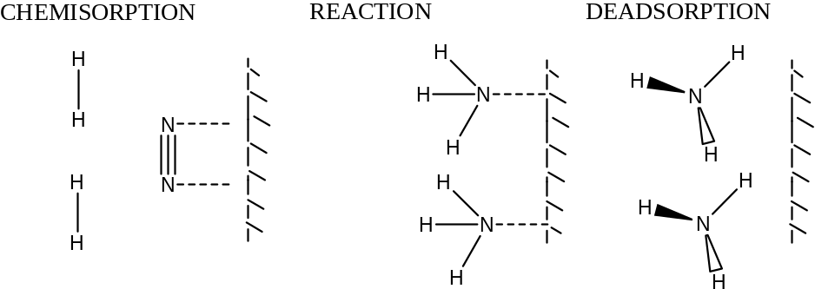

Homogeneous catalysts can form intermediates which contain the catalyst but then decompose to form products.

e.g. The reaction; A à B + C high activation energy

Catalysed reaction A + catalyst à A-catalyst low activation energy
Intermediate
A-catalyst à B + C + catalyst low activation energy

Note - The catalyst may change oxidation state during the reaction.

CHEMICAL EQUILIBRIA

Dynamic Equilibrium
Equilibrium involves reversible reactions which do not go to completion.

If we consider a reaction between A and B to form C and D which is reversible.
When A and B are mixed, the molecules will form C and D.
However, as soon as molecules of C and D are formed and collide they can also react to become A and B.
Such a reaction is written;
A + B C + D

The reaction reaches a point at which the proportion of each chemical becomes constant. This is described as equilibrium.

If the reactants are mixed, their concentrations will fall, rapidly at first, but then more and more slowly, until they settle to their “equilibrium” values. Meanwhile the amounts of products will increase, until they too achieve their equilibrium amounts.
The actual values of these amounts depend on the conditions.

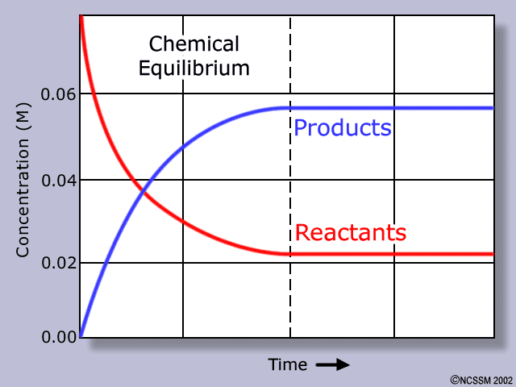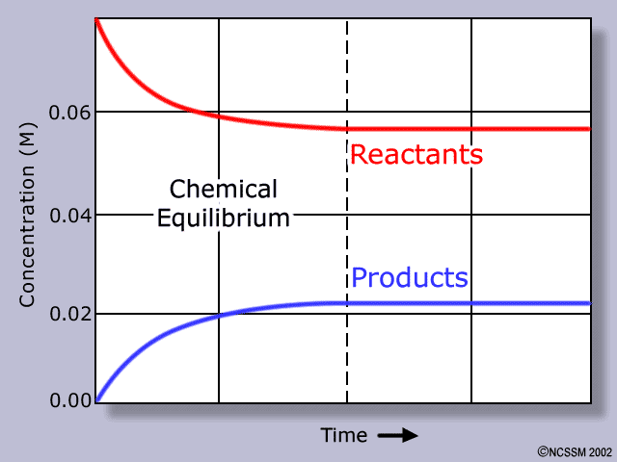

Equilibrium is when a reaction has a constant concentration of reactants and products.

When equilibrium is reached, the reaction has not stopped: instead, the rate at which the forward reaction is proceeding is exactly balanced by the rate of the reverse reaction. This is what is meant by “dynamic” equilibrium — individual molecules are reacting all the time, but the overall concentrations of the substances do not change.

Summary - at equilibrium:
- the system is closed (no substances can be added or lost).
- rate of forward reaction = rate of reverse reaction.
- all measurable variables are unchanging (concentration of each substance, pressure, temperature).

Effect of Conditions on the Equilibrium

The conditions which can be applied to a system are change in concentration, pressure, temperature and the use of a catalyst.

In an equilibrium there is a constant ratio between the concentration of reactants and products at a particular temperature.

Le Chatelier's principle states that when a reaction at equilibrium is subjected to a change in condition (temperature, pressure or concentration), the equilibrium composition / position alters to reduce the effect of the change.

Changing the Concentration
If the equilibrium is disturbed by changing the concentration of either reactants or products, the reaction will “shift” in order to re-establish the equilibrium.

Suppose that in a reaction E G
- There is an equilibrium ratio of concentration of 1 : 2.
- So if the equilibrium mixture contains 1 mole of E, then there will be 2 mole of G.
- If 0.6 mole of E is added, the equilibrium is disturbed and the ratio temporarily becomes 1.6 : 2
- The increased concentration of reactant causes the rate of the forward reaction to increase.
- This means that product is formed at a faster rate and its concentration increases.
- The system shifts to the right to re-establish the equilibrium.
- This will continue until an additional 0.4 mole of E has been converted to G, and the values become 1.2 : 2 .4
- The ratio of concentration is now back at 1 : 2,
- Equilibrium has been re-established.

In general, if the concentration of reactants is increased, the system can counteract this change by shifting to the right, so reducing the concentration of the reactants again.
This process increases the concentration of the products and continues until the ratio returns to its original value again.
During this process the reaction has shifted to the right.

Increasing the concentration of the products correspondingly moves the position to the left.

Increasing the concentration of a reactant causes a shift to the right.
Increasing the concentration of a product causes a shift to the left.

Changing the Pressure
Altering the pressure will effect a gas reaction if there are different numbers of moles of reactant and product in the equation.

For example in a reaction. 2J L

- If the pressure of the system is increased, the system reacts to counteract the increase. In the reaction above this means that the reaction will shift to the right, reducing the number of gas molecules present and so reducing the pressure.

J
J
J
L
The pressure of a given volume of gas will depend upon how many gas molecules there are in it.
J
J
L
J
J
J
L

J
L
L
As the pressure is increased, two J molecules form 1 L molecules, reducing the pressure of the gas.
J
L
L
L
J
J

In general:
Increasing the pressure of a gaseous reaction causes a shift towards the side with fewer gas molecules.
Decreasing the pressure of a gaseous reaction causes a shift towards the side with the larger number of gas molecules.

Changing the Temperature
An endothermic reaction is one that takes in heat energy and so causes a temperature decrease.

Endothermic reaction

If the temperature of an equilibrium reaction is increased, the system tries to counteract this change by reducing the temperature again by carrying out the endothermic reaction.

In general:
Increasing the temperature of a reaction causes a shift towards the endothermic reaction. Decreasing the temperature of a reaction causes a shift towards the exothermic reaction.
Adding a Catalyst
Catalysts do not alter the equilibrium constant or the position of equilibrium.
They do affect the time needed for the system to reach equilibrium.

Laboratory examples of equilibrium
The equilibrium
Cl_{2(g)} + ICl_{(l)} ICl_{3(s)}
Pale green Brown yellow

Iodine chloride is placed in a U tube and chlorine passed over it .
chlorine

As chlorine is passed into the system its concentration is increased.
The system acts to reduce the chlorine level again by shifting to the right.

Iodine chloride
Brown liquid
Iodine chloride
Yellow solid

The chlorine supply is then stopped

As the chlorine concentration is decreased.
The system acts to increase it again by shifting to the left.

The equilibrium

N₂O₄ 2NO₂ ΔH_{R}^{θ} = + 58 kJmol⁻¹
Heat
As the temperature is increasd, the system acts to oppose this change.
The cooling endothermic reaction is favoured and it shifts to the right.

The Haber Process

N_{2(g)} + 3H_{2(g)} 2NH_{3(g)} ΔH = -92kJmol⁻¹

Removing the of ammonia as soon as it forms will cause the position of equilibrium to move to the right and give a bigger yield of ammonia. (This is achieved by cooling the mixture as the ammonia turns into a liquid first).
When the pressure is increased the equilibrium shifts to the side with least gas molecules. , The reaction shifts from left to right, giving a bigger yield of ammonia.
A Haber process plants operate between 200-400 atmospheres pressure.

Decreasing the temperature leads to a higher yield of ammonia because the reaction from left to right is exothermic and causes the temperature to rise again if ammonia is formed.

In the Haber process a moderately high temperature of around 500ºC is used to speed the rate at which equilibrium is reached. This temperature is chosen in spite of the fact that a lower temperature gives a higher yield.

The optimum (best) conditions for this process which give the greatest yield are:
- 350 atmospheres; high pressure increases yield.
- about 450ºC ; high temperature cuts yield but increases rate.
- and the use of a catalyst, iron, to increase the rate.

Organic Chemistry - Halogenoalkanes and Alcohols

Halogenoalkanes

Halogenoalkanes contain a halogen as the functional group R-Hal.

The first part of the name of an halogenoalkane gives the position and name of the halogen concerned.
The second part of the name is based on the rest on the hydrocarbon structure.

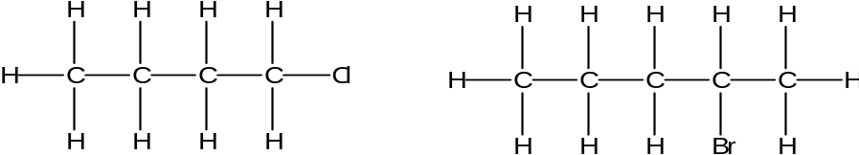
1-chlorobutane 2-Bromopentane

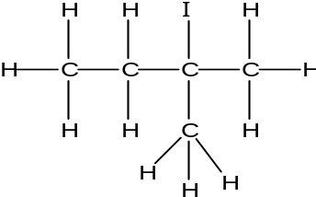
Cl
Cl
Br
2-Iodo-2-methylbutane

2,3-Dichloroheptane 3-Bromo-3-methylhexane

Types of Halogenoalkanes
There are three types of halogenoalkane; primary, secondary and tertiary.
They are classified according to the number of carbon groups attached to the carbon with the halogen, X, group.
H
H
H
C
X
R
H
H
C
X
R
H
R
C
X
R
R
R
C
X

Primary Secondary Tertiary
No or one carbon (R) group attached to the carbon with the X group is a primary halogenoalkane.
Two carbon (R) groups attached to the carbon with the X group is a seconary halogenoalkane.
Three carbon (R) groups attached to the carbon with the X group is a tertiary halogenoalkane

Chemical properties of Halogenoalkanes
Fluoroalkanes are different from the other halogen derivatives, since the C–F bond is so strong that they are very unreactive. Most of the discussion here will refer to RCl, RBr and RI.

Chloromethane, bromomethane, and chloroethane are gases, while the rest are liquids which do not mix with water as they do not have the ability to hydrogen bond.

Preparation of Halogenoalkanes
Halogenoalkanes are generally made by reacting the appropriate alcohol it with a halogenating reagents.
Halogenating agents include phosphorus pentachloride, sodium chloride with concentrated sulphuric acid, sodium bromide with concentrated phosphoric acid and phosphorus with iodine.

Phosphorus pentachloride reacts vigorously with alcohols at room temperature.
C₂H₅OH + PCl₅ → C₂H₅Cl + HCl + POCl₃

Choro- compounds can also be formed by heating the alcohol under reflux with sodium chloride and concentrated sulphuric acid.
H₂SO₄ + NaCl → HCl + NaHSO₄
HCl + C₃H₇OH → C₃H₇Cl + H₂O

To form a bromo- compound, the alcohol is heated under reflux with sodium bromide and concentrated phosphoric acid. The concentrated phosphoric acid reacts with the sodium bromide to form hydrogen bromide, and the hydrogen bromide carries out the substitution.
H₃PO₄ + NaBr → HBr + NaH₂PO₄
HBr + C₃H₇OH → C₃H₇Br + H₂O

To produce iodo- compounds, the alcohol is mixed with red phoshorus and iodine is added gradually. The mixture is then heated under reflux.
P + 1½I₂ → PI₃
PI₃ + 3CH₃CH(OH)CH₃ → 3CH₃CHICH₃ + H₃PO₃

Concentrated sulphuric acid cannot be used to make bromoalkanes or iodoalkanes as the halide ion is oxidized to the halogen.

Reactions of Halogenoalkanes

Halogenoalkanes commonly undergo nucleophilic substitution and elimination reactions.

Nucleophilic substitution reactions
A nucleophile is a species (molecule or negative ion) which can donate an electron pair in a chemical reaction.
Halogenoalkanes undergo substitution reactions with nucleophiles such as OH– and NH₃.

with potassium hydroxide.

Conditions: Heat under reflux in aqueous solution. Both NaOH or KOH are suitable.
C₂H₅Br + NaOH (aq) à C₂H₅OH + NaBr

with potassium cyanide
Conditions: Reflux solution of halogenoalkane and potassium cyanide in ethanol.
C₂H₅Br + KCN à C₂H₅CN + KBr
propanenitrile
This adds a carbon atom to the chain and forms a nitrile.

with ammonia
Conditions: Heat with concentrated ammonia in a sealed tube.
or heat with alcoholic ammonia.
C₂H₅I + NH₃ à C₂H₅ NH₂ + HI
Ethylamine (an amine)

Other products include: (C₂H₅)₂NH and (C₂H₅)₃N
Amines are molecules containing a N functional group.

Elimination reactions
If a halogenoalkane is boiled with potassium hydroxide solution in ethanol rather than water an elimination reaction takes place in which an alkene is formed and hydrogen halide is given off (eliminated).

Conditions: Heat under reflux with alkali and ethanol as solvent. Use KOH here.
CH₃CH₂Br à CH₂CH₂ + HBr

Identification of halogenoalkanes – Reaction with Silver nitrate solution.

In the presence of water, halogenoalkanes undergo hydrolysis.
The halogenoalkanes have a slightly polarised C-Hal bond. Water acts as a nucleophile towards the carbon atom in this bond. As a result , the -OH group substitutes for the halogen, giving an alcohol and a hydrogen halide.

The reaction is much slower than with an alkali.
RX + H₂O → ROH + HX

The hydrogen halide formed will dissolve in the water forming H⁺ and X⁻ ions. The ions then react with the silver ions in the solution producing a precipitate.
The appearance of the precipitate depends upon the halide ion generated in the hydrolysis reaction.
Ag⁺_{(aq)} + X⁻_{(aq)} → AgX_{(s)}

This reaction is used to test for halogenoalkanes.
- Heat sample of halogenoalkane with aqueous hydroxide ions.
- Acidify with dilute aqueous nitric acid.
- Add a few drops of aqueous silver nitrate.
- A white precipitate soluble in dilute aqueous ammonia, indicates chloride.
- A buff precipitate insoluble in dilute aqueous ammonia but soluble in concentrated aqueous ammonia, indicates bromide.
- A yellow precipitate insoluble in concentrated aqueous ammonia indicates iodide.

Reactivity of halogenoalkanes
Results of investigations show that the rate of hydrolysis of the halogenoalkanes occurs in the order:
1-iodobutane > 1-bromobutane > 1-chlorobutane
The ease of reaction depends on the ease of breaking the C-Hal bond:

Bond : C-I C-Br C-Cl C-F
Bond enthalpy terms (kJ mol⁻¹ ): +238 +276 +338 +484
Thus the ease of bond breaking is, C-I > C-Br > C-Cl > C-F.

(This outweighs the effects caused by greater polarization in the C-Hal bond).

Uses of halogenoalkanes

Halogenoalkenes are use as fire retardants and refrigerants as they are unreactive and particularly for the fire retardants they are non-combustible.

Freon 12 CF₂Cl₂ is a refrigerant and an example of a chlorofluorcarbon (CFC). The C-F and C-Cl bonds are very strong. The result is that it does not decompose easily so lasts for the lifetime of a refrigerator. It does not decompose quickly when discarded but does so in the upper atmosphere. The radicals it forms react with ozone. The loss of ozone leads to an increase in UV radiation reaching the Earth's surface and a corresponding increase in skin cancers in humans.
Modern refrigerants are hydrofluorocarbons, HFCs, such CF₃CH₂F. They do not lead to ozone depletion.

PVC used as electrical insulator -[-CH₂-CHCl-]_{n}-
The C-Cl bond is strong so PVC insulation lasts a long time but when discarded it does not rot (it is not biodegradable).

Teflon, or poly(tetrafluoroethene) is essentially poly(ethene) chains in which all the H atoms have been replaced by fluorines: –CF₂–CF₂–CF₂–CF₂–CF₂–CF₂–CF₂–CF₂–CF₂– etc. It is used to line non-stick frying pans and saucepans, and for low-friction bearings. As the C-F is very strong it is non-biodegradable.

DDT is a pesticide used to kill mosquitos. CCl₃ |
Cl-C₆H₅-C-C₆H₅-Cl
|
H
The strong C-Cl bonds give DDT a long life in the field killing pests. It is however so long lived that it persists in the environment and builds up in the food chain threatening creatures at the top of the chain.
Alcohols

Alcohols contain the -OH functional group.
General formula – C_{n}H_{2n+1}OH

The first part of the name of an alcohol is according to the longest carbon atom sequence. The second part of the name is –ol. A number will be included to indicate the position of the alcohol group.

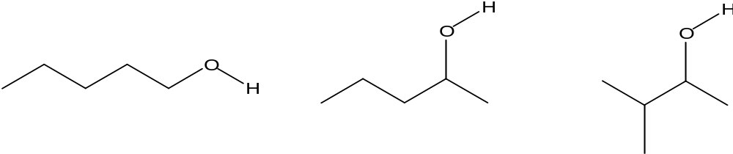
Pentanol or pentan-1-ol Pentan-2-ol 3-methylbutan-2-ol

Types of Alcohol
There are three types of alcohol; primary, secondary and tertiary.
They are classified according o the number of carbon groups attached to the carbon with the OH group.
H
H
H
H
C
O
R
H
H
H
C
O
R
H
H
R
C
O
R
H
R
R
C
O

Primary Secondary Tertiary

No or one carbon (R) group attached to the carbon with the OH group is a primary alcohol.
Two carbon (R) groups attached to the carbon with the OH group is a secondary alcohol.
Three carbon (R) groups attached to the carbon with the OH group is a tertiary alcohol.

Physical properties of alcohols
The OH group can take part in hydrogen-bonding, both as a donor (H is sufficiently δ+) and as an acceptor (through the two lone pairs on the oxygen atom). As a result alcohols have higher melting and boiling points than hydrocarbons of comparable molar mass.

They are also more soluble in water because of H-bonding: ethanol is miscible with water in all proportions. As the non-polar hydrocarbon chain becomes longer, it becomes harder for water to dissolve the alcohol: from C₄ alcohols are less soluble, and don’t mix with water.

Reactions of Alcohols
Combustion
All alcohols undergo combustion to form carbon dioxide and water. For example the equation for the combustion of butanol is as follows;
C₄H₉OH + 6O₂ → 4CO₂ + 5H₂O

Reaction with sodium
All alcohols react with sodium.
2ROH + 2Na → 2RONa + H₂
This equation is similar to the reaction of sodium with water, except that an alkoxide is formed rather a hydroxide.

e.g. Ethanol and sodium 2C₂H₅OH + 2Na → 2 C₂H₅ONa + H₂
Sodium ethoxide

Reaction with phosphorus pentachloride
All alcohols react with phosphorus pentachloride.
This is used as a test for the -OH group. The presence of the OH group can be shown by adding phosphorus pentachloride to the compound. A reaction takes place forming hydrogen chloride which appears as steamy white fumes.
ROH + PCl₅ → RCl + POCl₃ + HCl
In the reaction with phosphorus pentachloride a chloro group replaces the -OH group.

e.g. Propanol and phosphorus pentachloride
CH₃CH₂CH₂OH + PCl₅ → CH₃CH₂CH₂Cl + POCl₃ + HCl

Reaction with other halogenating agents
Alkyl bromides can be made from the reaction of an alcohol with HBr.
HBr is made in situ from KBr and H₂SO₄ forms bromoalkanes during heating under reflux.
C₂H₅OH + HBr à C₂H₅Br + H₂O

Alkyl chlorides can be made by refluxing the alcohol with conc. HCl in the presence of ZnCl₂
C₂H₅OH (l) + HCl (g) à C₂H₅Cl (l) + H₂O (l)
Iodoalkanes can be made in a reaction phosporus triiodide from iodine and red phosporus.
3C₂H₅OH + PI₃ à 3C₂H₅I + H₃PO₃
The relative reactivities of alcohols in halogenation are tertiary > secondary > primary alcohol.
Oxidation of alcohols

Primary and secondary alcohols can be oxidised by heating with a mixture of dilute sulphuric acid with sodium or potassium dichromate(VII) solution.

Acidified dichromate(VI) solution is produces a colour change from orange to blue-green when it has undergone oxidation reactions.

In writing equations for these oxidation reactions [O] is used to represent the oxidising agent.

Primary alcohols form an aldehyde, and then on further oxidation, form carboxylic acids.
R
H
H
H
C
O
C
H
O
R
C
O
R
H
O

Primary alcohol Aldehyde Carboxylic acid

Secondary alcohols form ketones, but no further oxidation takes place.
R
H
H
R
C
O
C
R
O
R

Secondary alcohol Ketone
e.g. CH₃CH(OH)CH₃ + [O] à CH₃COCH₃ + H₂O
propan-2-ol propanone
Tertiary alcohols do not react with oxidizing agents.

Partial Oxidation to aldehydes
e.g. ethanol to ethanal.
CH₃CH₂OH + [O] → CH₃CHO + H₂O

To make the aldehyde, the one reagent is added dropwise to the other and the product is distilled off as it forms.

By distilling the aldehyde off as it forms, it means it will not undergo further oxidation to the acid.

Heat

Total Oxidation to Carboxylic acids
e.g. ethanol to ethanoic acid. The mixture of reagents is heated under reflux.
CH₃CH₂OH + 2[O] → CH₃CO₂H + H₂O

Heating under reflux

The apparatus shown here is used a large number of organic preparations.

The reaction mixture is placed in the pear shaped flask. It has a reflux condenser* fitted. This means that as the reactants are heated and the volatile liquids boil off, they are converted back to liquid in the condenser and return to the flask.

*A reflux condenser “is not a special type of condenser, it is an ordinary condenser fitted so that reflux takes place.

Heat

Once the carboxylic has been formed, it needs to be separated from the reaction mixture and other products. This is done by distillation.

Distillation is used to separate a volatile product from a mixture of involatile substances, or substances that have a boiling point of at least 50ºC higher than the component being collected.

Heat

REACTION MECHANISMS

Reaction Classification
The table below reviews the organic reactions studied for AS chemistry, how they are classified and the reaction mechanisms where required.

Reaction | Reaction classification | Reaction mechanism
Alkane and halogen | Substitution | Free radical substitution
Alkene and H₂ | Addition (reduction)
Alkene and halogen and HBr | Addition | Electrophilic addition (Br₂)
Alkene and hydrogen halide | Addition | Electrophilic addition (HBr)
Alkene and KMnO₄ | Oxidation
Alkene polymerization | Polymerization
Alcohol with H₂SO_{4(aq)} and K₂Cr₂O₇ | Oxidation
Alcohol with halogenating agents | Substitution | Nucleophilic substitution
Halogenoalkanes and KOH_{(aq)} | Substitution | Nucleophilic substitution
Halogenoalkanes and KOH_{(eth)} | Elimination
Halogenoalkanes and water | Substitution / Hydrolysis | Nucleophilic substitution
Free radical reactions
A typical example of these is between an alkane and a halogen.
e.g. methane and chlorine. They involve an attack by an atom or group with an unpaired electron called a free radical. In the above reaction ultraviolet light causes chlorine atoms (free radicals) to form, Cl. and methyl radicals, CH₃. are also involved. The dot shows the unpaired electron.
Electrophilic addition reactions
A typical example of these is between an alkene and a hydrogen halide. e.g. ethene and hydrogen bromide. They involve an attack by an ion or group with a positive or partial positive charge called an electrophile. In the above reaction the electrophile is a hydrogen ion H⁺. Electrophiles attack centres of negative charge like the electrons in a double bond. These are addition reactions because the two reactants are added together to give one product.
e.g. C₂H₄ + Cl₂ à CH₂ClCH₂Cl
Nucleophilic substitution reactions
A typical example of these is between an alcohol and hydroxide ions. e.g. ethanol and aqueous sodium hydroxide. They involve an attack by an ion or group with a negative or partial negative charge called a nucleophile. In the above reaction the hydroxide ion OH⁻ is the nucleophile.
A nucleophile attacks a centre of positive charge such as the partial positive charge on the carbon atom holding a halogen C^{δ+}-X. It is a substitution reaction because the attacking species replaces the species originally attached to the carbon atom under attack.
e.g. CH₃CH₂Br + OH⁻ à CH₃CH₂OH + Br⁻

Elimination reactions
A typical example is the formation of an alkene from an alcohol. E.g. Ethanol reacting to form ethene. They involve atoms or groups from either side of a single carbon to carbon bond being removed (eliminated) to form a double bond.
e.g. CH₃CH₂OH à C₂H₄ + H₂O
Hydrolysis reactions
These all involve a reaction with water.
e.g. CH₃CH₂Br + H₂O à CH₃CH₂OH + HBr
Reduction reactions
These involve a reaction with hydrogen. A compound gains hydrogen. This can be hydrogen H₂ or from a reducing agent like LiALH₄ in ether or aqueous NaBH₄.
e.g. CH₃CHO + 2[H] à CH₃CH₂OH
Oxidation reactions
These reactions involve the loss of hydrogen or the gain of oxygen. An oxidising agent like acidified potassium dichromate (VI) is used.
e.g. CH₃CH₂OH + 2[O] à CH₃COOH + H₂O
Polymerisation reactions
These reactions involve the joining of small molecules called monomers to make large molecules called polymers. A large number (n) of monomer molecules in involved and a long polymer molecule is formed.
e.g. nC₂H₄ à -(C₂H₄)_{n}-

Classification of Reagents
Chemists aim to develop a systematic approach to chemical reactions. In order to do this for organic chemistry it is useful to classify types of compound and how they behave. It is also useful to classify reagents so that predictions can be made about the most effective way of carrying out a new reaction.

Reagents can be classified in various ways including oxidising agents, reducing agents and chlorinating agents.
Bond Breaking and Reaction Mechanisms
Reaction mechanisms were introduced in Unit 1 as the study of the step by step processes involved in a reaction.

All reaction mechanisms involve looking at bond breaking.
There are two ways in which bond breaking takes place; homolytic and heterolytic.

In a homolytic process, the bond breaks so that the atoms on each side of the bond being broken receive one of the electrons from the bonding pair.
X
X
X
X

The single headed curly arrows represent the movement of one electron.

Homolytic fission involves the formation of radicals. A radical is an atom or group of atoms with an unpaired electron.
In a heterolytic fission process, the bond does not split the electrons evenly, but both electrons go to one of the atoms on one side of the bond.
X
X
X
X
+
-

The species formed by this process are ions; a cation and an anion.

The cation, because of the positive charge, will be attracted to a region of negative charge. It has a vacancy for two electrons, so it tends to accept an electron from another atom and form a bond. Such a species is called a nucleophile. A carbon atom possessing a positive charge is called a carbocation.

The anion, because of the negative charge, will be attracted to a region of positive charge. It has two electrons available, so it tends to donate an electron to another atom and form a bond. Such a species is called an electrophile. A carbon atom possessing a negative charge is called a carbanion.

Definitions
Three important definitions are given here.

Free radical - A free radical an atom or group of atoms with an unpaired electron.

Nucleophile - A nucleophile is a species attracted to a region of positive charge
and is an electron pair donor.

Electrophile - An electophile is a species attracted to a region of negative charge
and is an electron pair acceptor.

Bond type and Reaction Mechanism
The nature of bond present in a compound will determine what type of mechanism takes place in a reaction.

A halogenoalkane, for example, will have a polar bond because of the electrogativity of the halogen. This leaves the carbon bonded to the halogen with a partial positive charge. This makes the carbon with the partial positive charge susceptible to nucleophilic attack.

Alkenes have a double bond which has a high electron density. The high electron density creates a region of higher negative charge and so invites electrophilic attack.

Reaction Mechanisms
The following reaction mechanisms have been studies in Unit 1:

- The reaction of methane with chlorine – Photochemical free radical substitution

- The reaction of bromine and hydrogen bromide with ethene – Electrophilic addition

- The reaction hydrogen bromide with propene - Electrophilic addition

Mechanisms in Unit 2

Substitution reaction in halogenoalkanes
Halogens are electronegative and draw electrons away from the carbon atom leaving it with a partial positive charge. This is susceptible to attack by a nucleophile. There are two different nucleophilic substitution mechanisms.

With primary halogenoalkanes the nucleophile approaches the carbon atom and begins to form a bond. At the same time to bond with the halogen begins to break, with both electrons in the bonding pair going to the halogen.
Looking at dot and cross diagram for the reaction. This is not the way the mechanism is shown.
H
H
H
C
X
δ+
δ-
1. The halogen in the halogenoalkane is electronative so draws the bonding electron pair towards itself and creating a partial positive charge on the carbon.

H
H
H
C
X
δ+
δ-
2. The partial positive charge on the carbon invites attack of nucleophiles such as a hydroxide ion.

3. The hydroxide ion donates an electron pair to the carbon and starts to form a bond.

-
O
H

H
4. An intermediate is formed with the C-O bond forming and the C-X bond breaking.
-
X
C
O
H
H
H

This reaction involves two species (the halogenoalkane molecule and hydroxide ion) in the slow (bond breaking) step and is designated S_{N}2.

The mechanism is shown as follows;
C
H
X
H
H
HO
-

C
H
X
H
H
HO
-
C
H
H
H
HO

X
-

With tertiary halogeonalkanes, the carbon groups around the carbon with the halogen attached stabilise the ion, so allowing the ion to form. Once the ion has been formed the hydroxide ion can join in place of the halogen. The intermediate formed, the carbocation, is planar, so the hydroxide ion can attack from either side.
+
C
R
R
R
C
R
X
R
R
X
-
C
R
OH
R
R

HO
-

If the hydroxide ion attacked from the opposite side from that shown, the product would be the mirror image of the molecule above.

In these reactions, the slow step is the breaking off of the halogen and this involves only the halogenoalkane, that is one species, and it is designated S_{N}1.

Independent research
Research the formation of ozone in the upper atmosphere, the free radical reaction mechanisms involved in the breakdown of this ozone and the part played by aircraft emission of nitrogen oxides.

Green Chemistry

Green Chemistry refers to the processes in the chemical industry that are being reinvented to make them more sustainable. The term sustain means to keep going. If we use resources faster than they can be replaced, clearly this is a situation that cannot keep going. Sustainability is about living in a way that preserves resources and the environment for future generations.

The idea of “green chemistry” is to obtain all the valuable products, but in ways that do not damage the environment. Green chemistry is about making the chemical industry more sustainable.

The Chemical industry needs to become greener to;
- Reduce waste.
- Develop more economically viable processes.
- Reduce their environment impact.
- Save limited resources.

Five ways in which the Chemical industry can become Greener
- Change to renewable resources.
- Find alternatives to very hazardous chemicals.
- Discover catalysts for reactions with high atom economies,
e.g. the development of methods used to produce ethanoic acid based on catalysts
of cobalt, rhodium and iridium
- Make more efficient use of energy,
e.g. the use of microwave energy to heat reactions in the pharmaceutical industry
- Reduce waste and prevent pollution of the environment.

Changing to renewable sources
If renewable resources replace non-renewable materials raw materials will be conserved and the process becomes more sustainable. Plants can be used as a source of certain organic compounds instead of oil. These can be extracted directly from plants or derived from processing plant material, such as using fermentation to produce ethanol from plant starch and sugars.

Use of alternatives to hazardous chemicals
This involves replacing dangerous chemicals used in a process with less harmful chemicals which can do the same job. It includes changing processes so that less risky reagents are used or less destructive intermediates are formed. It also includes using less damaging solvents for a process.

Use of more efficient catalysts
Introduction of more efficient catalyst enables lower temperatures and pressures to be used and so saves energy. More efficient catalysts create fewer bye-products and so reduce waste.

Reduction of energy use
Changing to processes that use lower pressures and temperatures reduce the energy required to make a given product. Use of exothermic reactions to provide heat reduces the amount of non-renewable energy used, for example introducing a heat transfer system (using hot products to heat incoming reactants). Use of microwaves instead of hotplates allows more efficient heating, as it heats the relevant molecules directly.

Reduction in the amount of waste
Recycling materials means that less waste is produced. Making biodegradable products means that they can be broken down by natural processes and so reduce the materials that need to be treated after use.

Examples
Polylactic acid
An example of this is the production of the biodegradable plastic, polylactic acid, PLA. The lactic acid, 2-hydroxypropanoic acid, for this process can be produced by using bacteria to carry out the conversion from plant starch and sugars.

C
O
H
O
C
H
H
C
H
H
H
O
C
O
n
C
H
H
C
H
H
+ nH₂O
O
n

Since lactic acid is a substance produced by living organisms it means that the PLA is biodegradable.

Roundup
A new process for the production of a herbicide called “Roundup” was developed. The original process required the use of methanol (toxic) and hydrogen cyanide (extremely toxic), but the new process, using a copper catalyst, does not use these materials. The new process utilizes endothermic reactions, so it is safer and easier to control. The original process produced 14% waste, whereas the new process re-uses the catalyst and recycles any other unconverted chemicals, and so has no waste. The new process uses fewer steps and so produces a higher yield.

Ethanoic acid
Ethanoic acid can be manufactured from methanol and carbon monoxide:
CH₃OH + CO → CH₃CO₂H
A new process uses a combination catalyst consisting of iridium with ruthenium compounds. This catalyst produces purer ethanoic acid and so reduces the energy required for the purification.

Summary
The table below summarises which of the new processes fulfills the five main ways of making the chemical industry more sustainable.

 | PLA | Roundup | Ethanoic acid
Renewable resources | Yes
Alternative to hazardous chemicals |  | Yes
Development of new catalyst |  | Yes | Yes
More efficient energy use |  |  | Yes
Reduction in waste | Yes | Yes

Main Industrial Effects on the Environment

Global Climate Change
Products or waste products may enter the atmosphere and absorb Infra red radiation, thus leading to increased global climate change - anthropogenic climate change
e.g. Carbon dioxide, methane.

Acid Rain
Products or waste products may enter the atmosphere and dissolve in clouds to form acid rain, thus leading to change of soil pH and river water pH etc.
e.g. Sulphur dioxide, nitrogen oxides, carbon dioxide.

Ozone Depletion
Products or waste products may enter the atmosphere and lead to ozone depletion, thus leading to increased levels of UV radiation reaching the Earths surface.
e.g. CFC’s, products from combustion of plastics and Nitrogen oxides.

Climate change
One of the key concerns of sustainability is preventing damage to the environment. The atmosphere is a vital part of the Earth’s environment, and so the effect of people’s activities on the atmosphere needs to be understood and monitored.

The Earth receives radiation from the sun. This arrives mainly as visible light and ultra-violet radiation. Certain proportions of this radiation are absorbed by the atmosphere or reflected into space. About half of it reaches the surface of the Earth, where it is absorbed and re-radiated, but at a lower energy; in the infra-red frequency.
Visible and ultra violet light from the sun

Some gases in the atmosphere absorb infra-red radiation

Some light is absorbed in the atmosphere and some is reflected into space

Half the light reaches the Earth’s surface where it is absorbed and re-radiated in the infra-red.

Some gases in the atmosphere absorb infra-red radiation. Nitrogen and oxygen, the main gases in the atmosphere do not absorb infra-red radiation as they are completely non-polar. Gases composed of polar molecules do absorb infra-red radiation. When the molecules absorb infra-red they increase their vibration and their kinetic energy, which of course increases to temperature. Such gases are therefore called “greenhouse gases” and can be responsible for climate change or global warming. Carbon dioxide, water vapour and methane are the main greenhouse gases.

The atmosphere naturally contains a certain level of carbon dioxide, but human activity increases these levels. The effects of human activity are called anthropogenic effects. Scientists are able to use computer projections to plot the expected climate based on there being no anthropogenic carbon dioxide. When these projections are compared with plots of global temperatures, they show clearly that it is the anthropogenic carbon dioxide that is responsible for climate change.

The extent to which human activity placed carbon dioxide into the atmosphere can be measured by use of the “carbon footprint”. The carbon footprint is the quantity of carbon dioxide a certain item or activity places into the air in a complete cycle. The carbon footprint is measured in tones of carbon dioxide. If any item or process, when input and output of carbon dioxide is considered, does not add any carbon dioxide to the atmosphere, it is designated carbon neutral.

Alternative fuels
Use of fossil fuels as energy sources for vehicles, power generation plants or domestic heating is one of the key activities which places carbon dioxide into the atmosphere. If these can be made carbon neutral or have their carbon footprint reduced, it is advantageous to the environment.

One way of reducing the carbon footprint is to use biofuels. The principle of a biofuel is that they are formed by plants that take up carbon dioxide from the air to make the plant material which is then converted into fuel, and when the fuel is burnt, it simply puts back into the air the carbon dioxide it originally removed, so overall it does not add to the carbon dioxide level, and can therefore be described as carbon-neutral.

This simple view of biofuels does not however provide the full picture. Bioethanol for example is produced from sugar cane in Brazil and from maize in the USA. The production of ethanol in the USA uses fertilizers and pesticides which have taken energy (form oil) to make. The ethanol then needs to be separated by distillation, a process again which uses energy from oil. Biodiesel is more effective in reducing the carbon footprint because it does not require distillation.

Hydrogen is a much better alternative fuel as it only produces water when it is burnt. The key point about hydrogen is how it is produced. If it is made by electrolysis using mains electrical supply, it can still have a large carbon footprint if the electrical generation involves the combustion of fossil fuels. In the same way hydrogen generated by the reaction of methane with steam, the final products being hydrogen and carbon dioxide, has a significant carbon footprint. Hydrogen produced by electrolysis, where the electrical energy was derived from sunlight would of course be very environmentally friendly.

The ozone layer and CFCs
The atmosphere is composed of several layers. Most pollutant molecules are broken down before they reach the upper atmosphere. However it is possible for some particularly stable molecules to enter the upper atmosphere. One such type of molecule are the chlorofluorocarbons, CFCs, which are stable because of the strength of the C-F bond. These were used in aerosols and refrigerants. When they enter the upper atmosphere, the CFCs can damage the “ozone layer”.

The ozone layer is formed by the energy from the sun’s ultra violet radiation being able to split an oxygen molecule into two oxygen atoms.
O₂ 2O·

The oxygen atom formed can then combine with an oxygen molecule to form ozone, O₃.
O₂ + O· O₃

The ozone formed is able to absorb harmful ultra violet radiation from the Sun, so protecting the Earth’s surface from these rays. When this happens the reaction above is reversed.
O₃ O₂ + O·

In the 1980s it was discovered that this protective ozone layer was diminishing during the summer over the Antarctic and that the “hole” was increasing in size. Chemists tracked the cause down to the CFCs. The stability of CFCs means that they are not broken down in the lower atmosphere, but when they reach the upper atmosphere the uv radiation causes the C-Cl bond to be broken forming Cl· radicals. These radicals then react with ozone as follows:
O₃ + Cl· O₂ + ClO·

The radical then proceeds to react with the oxygen atoms present in the stratosphere:
O· + ClO· O₂ + Cl·
This reaction removes oxygen atoms that could otherwise generate more ozone, but it also regenerates the Cl· radical, allowing a series of reaction to take place similar to the propagation stages of the chlorination of methane. It is estimated that one Cl· radical can breakdown a million ozone molecules.

As a result scientists recommended the phasing out of CFCs. In 1987 a United Nations conference was held in Montreal to tackle the problem and an agreement was established in which there would be a phased reduction in the use of CFCs leading to an eventual ban. This agreement was called the Montreal Protocol.

